PATHSHALA NEPAL FOUNDATION

PRE-UNI PROGRAM

Baneshwor, Kathmandu



Lab Assessment Report on

Structure in C

**Submitted By:** **Submitted To**

Name: Raunak Raj Adhikari Department of Computer Science

Class: 12 PATHSHALA NEPAL FOUNDATION

Group: 2

Date: 2023-09-07

**ANSWER THE FOLLOWING:**

1. Define structure. Explain how structure is used in a C program. (Discuss briefly with reference to syntax.)
2. Show the difference between array and structure.
3. What type of problems do you think the use of structure is essential?
4. Show the difference between structure and union.
5. 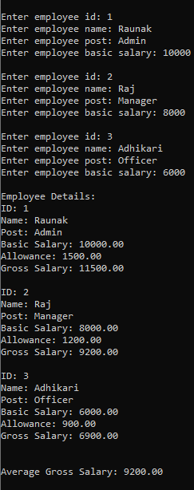Write a program that reads employee id, name, post and basic salary of **THREE employees**, calculate allowance as 15% of the basic salary and gross salary for each employee, and display them in the proper format along with the calculation of average gross salary of all. 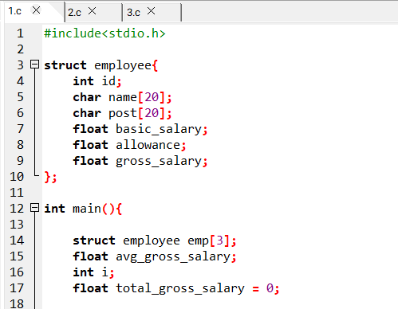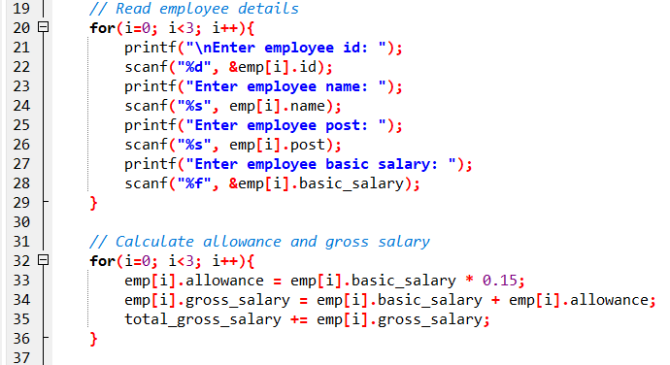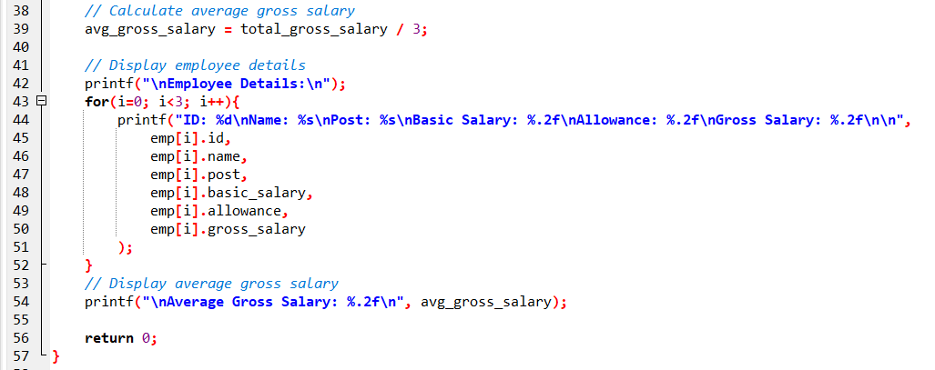

**Output:**

1. Write a program that reads employee id, name, post and basic salary of **15** employees andcalculate allowance as 15% of the basic salary and gross salary for each employee, and display them in the proper format along with the calculation of average salary of all.

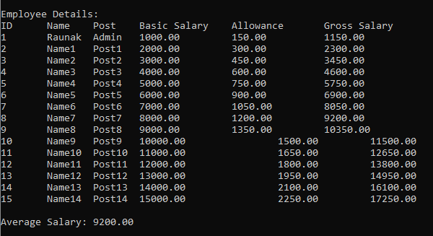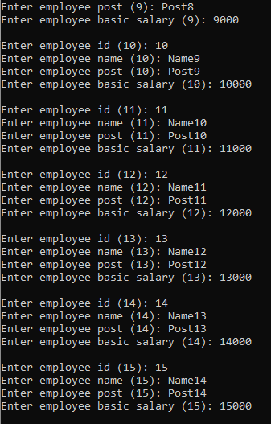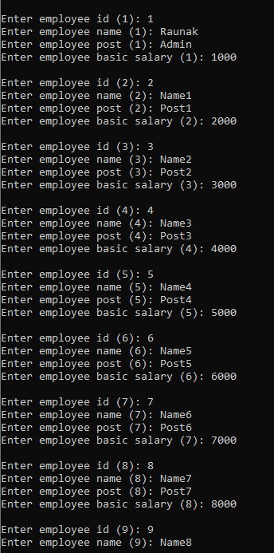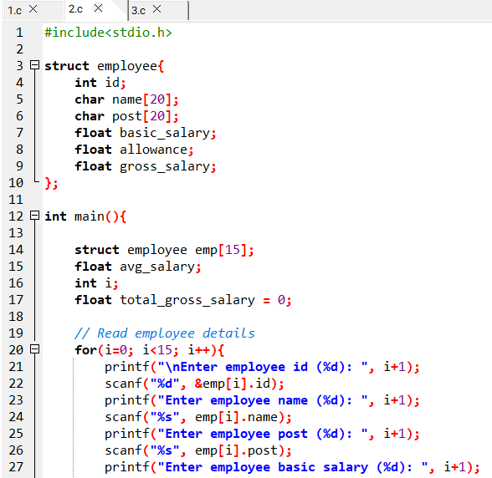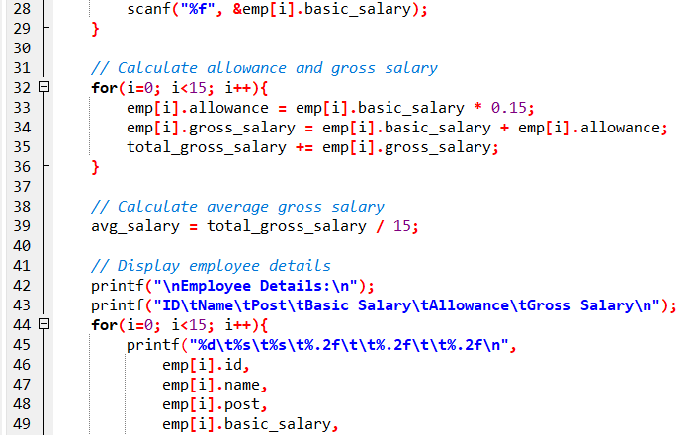

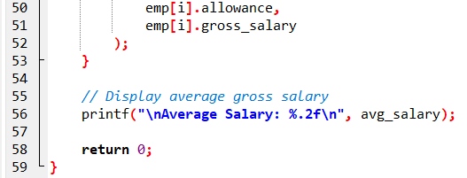

1. Write a program that reads employee id, name, post of **N** employees display them in the proper format after calculating the values as stated below:

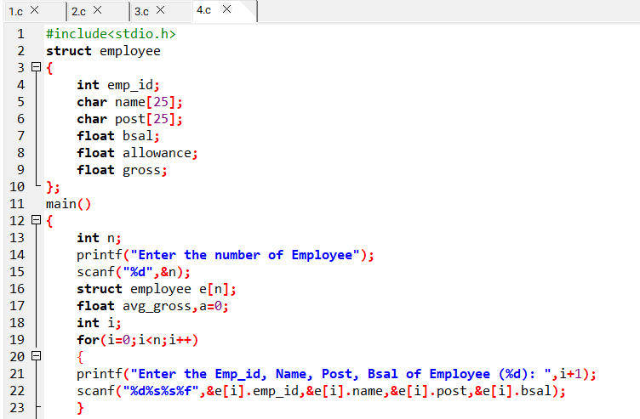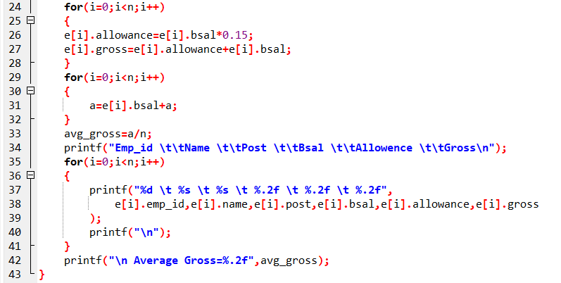

**Output:**

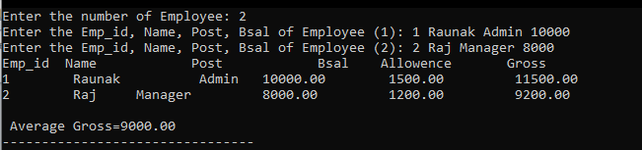

1. Write a program that reads the registration number (regno), name, and marks in 6 different subjects of 10 students and display them in the proper format along with the calculation of total and percentage. The format if records should be as follows:

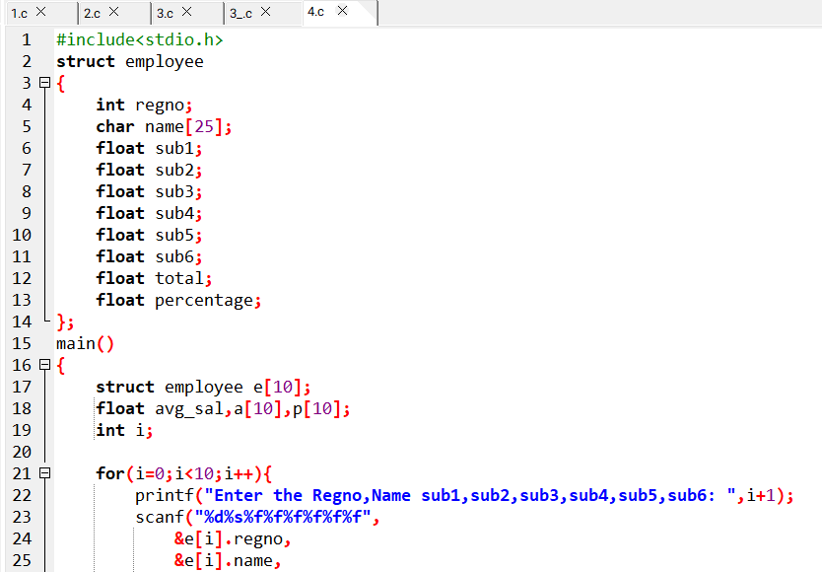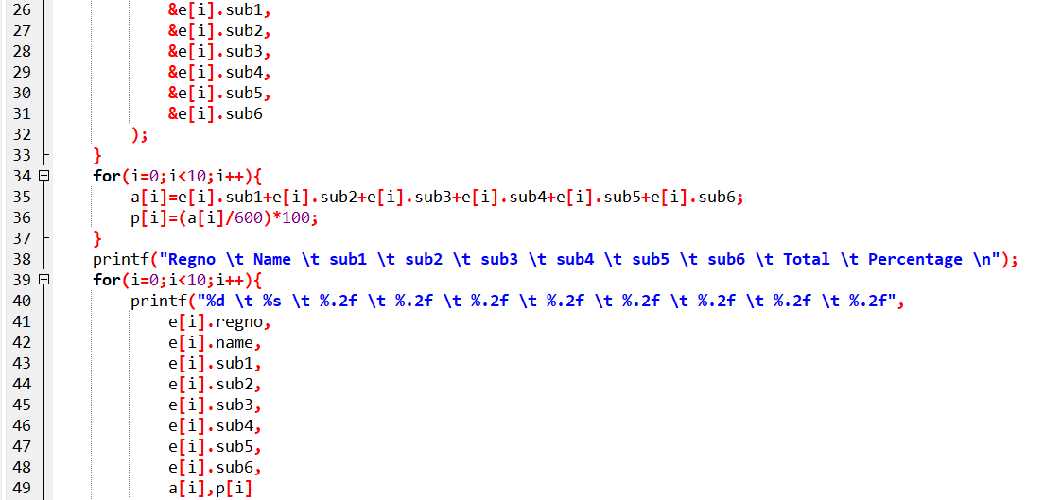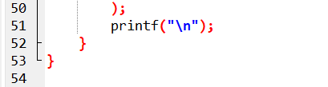

**Output:**

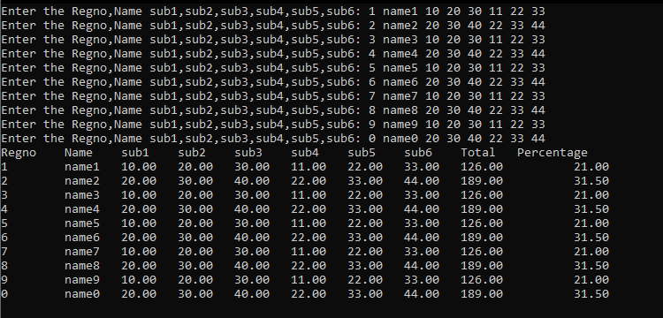

1. Write a program that reads the registration number (regno), name, and marks in 5 different subjects of n different students and display them in the proper format along with the calculation of total and percentage and result following the criteria as listed below:

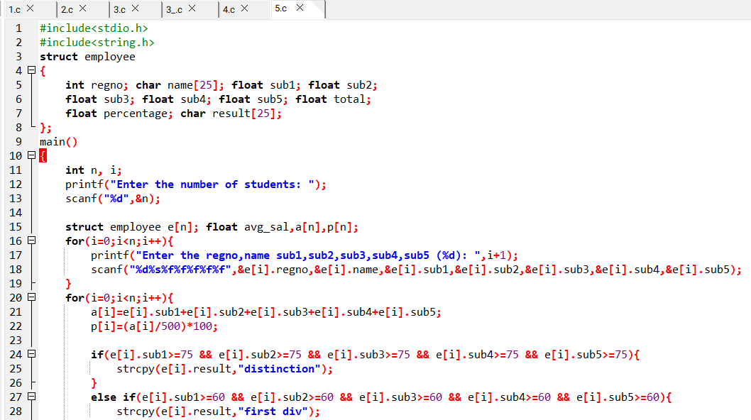 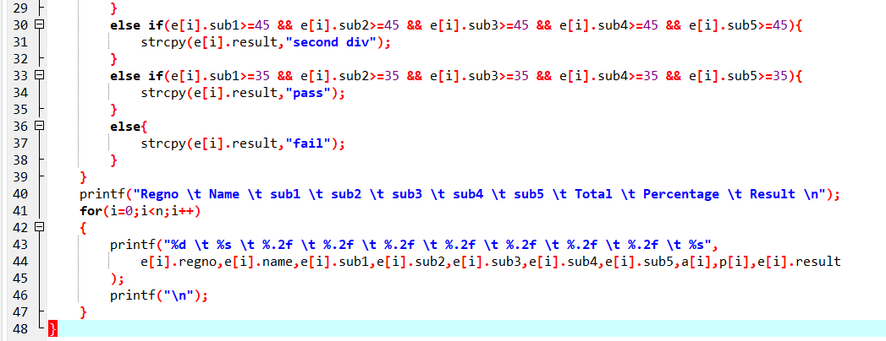

**Output:**



1. Write a program that reads the regno, name, gender, class and address of 15 students and display all the records in the proper format arranging them in alphabetic order to their name.

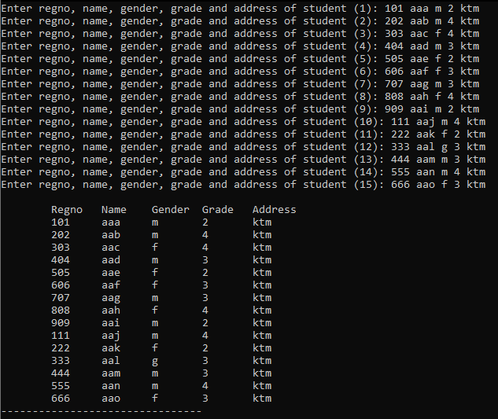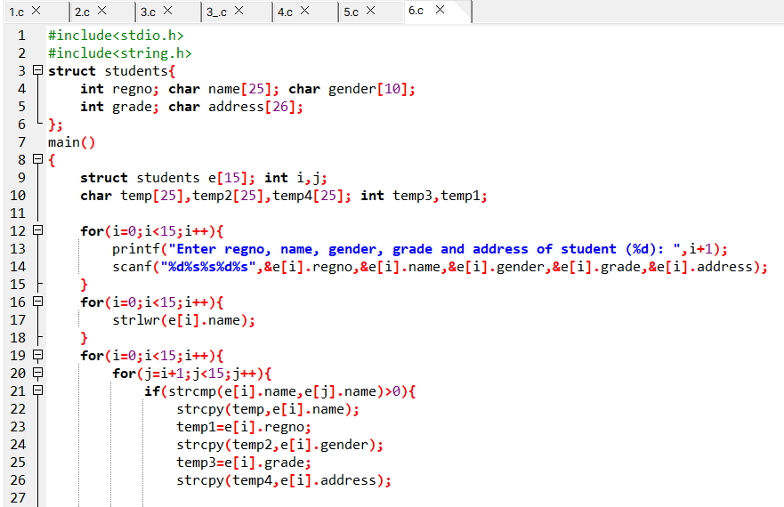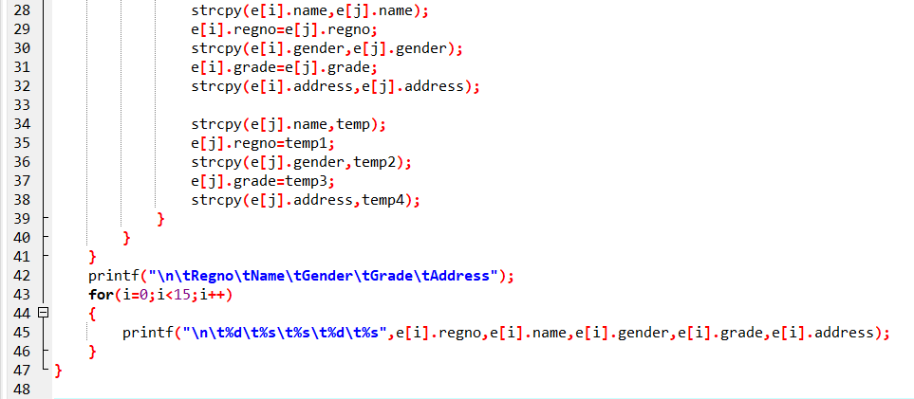

**Output:**

1. Write a C program to introduce nested structure for the management of employee’s detail as illustrated below:

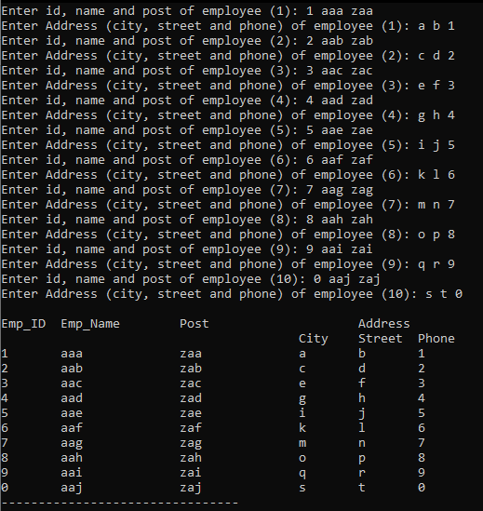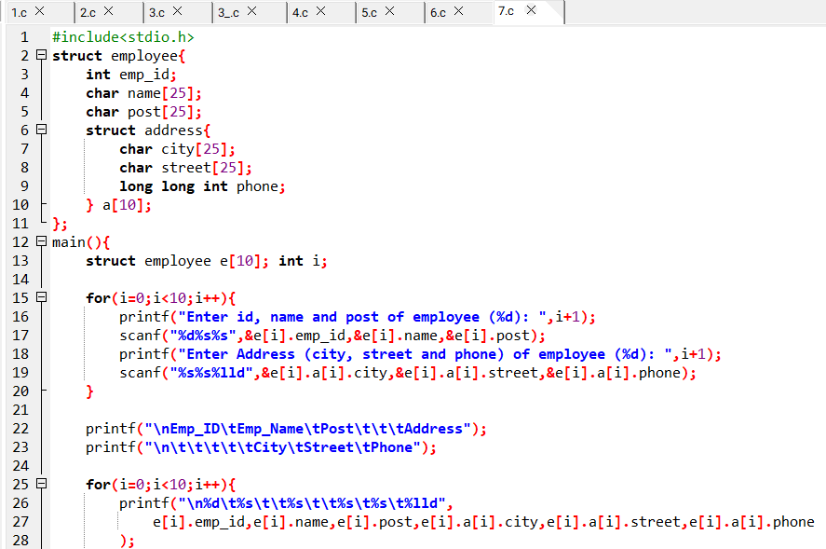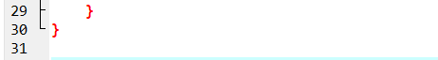

**Output:**